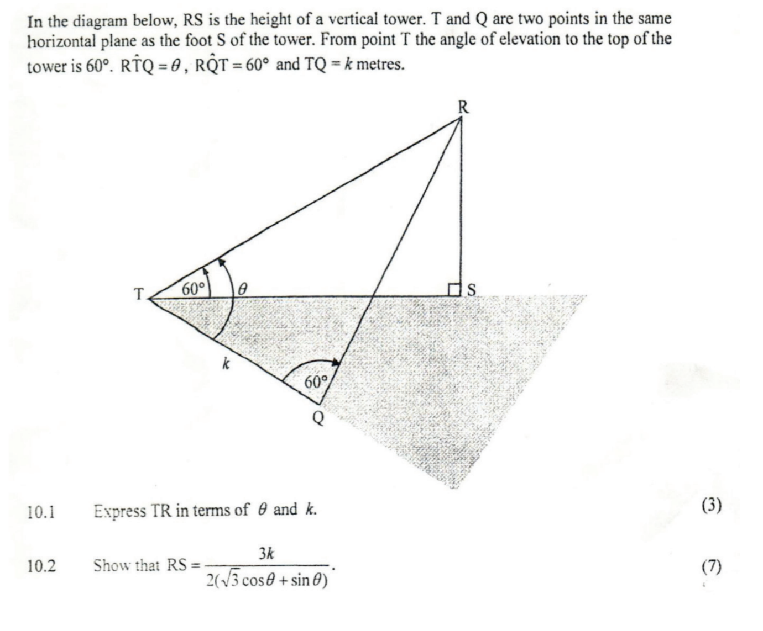

cos60 = = =

TS =

RS = =

<https://www.symbolab.com/solver/step-by-step/simplify%20%5Csqrt%7Bk%5Cleft(%5Cleft(k%2B%5Cleft(%5Cfrac%7B2sinx%7D%7B%5Csqrt%7B3%7Dcosx%2Bsinx%7D%5Cright)%5E%7B2%7D-%5Cfrac%7Bsinx%7D%7B%5Csqrt%7B3%7Dcosx%2Bsinx%7D%5Cright)-k%2B%5Cleft(%5Cfrac%7B%5Cfrac%7Bsinx%7D%7B%5Csqrt%7B3%7Dcosx%2Bsinx%7D%5Cleft(4sinx-1%5Cright)%7D%7B4%7D%5Cright)%5Cright)%7D>

Where x = :

